Race Work

Michael Samuel

January 28, 2019

### * All-Cause age-adjusted death rates have been decreasing for all race/ethnic groups in recent years (and for maany decades prior).

### * The decrease has been proportionally most rapid for Afircan Americans

### * Nevertheless, this death rate is higher for African Americans across all year-periods

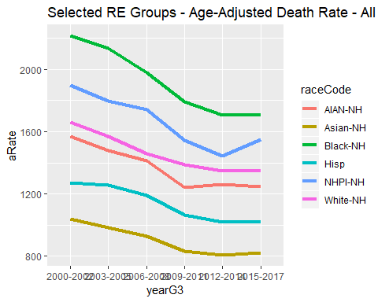

### *Kidney Disease…

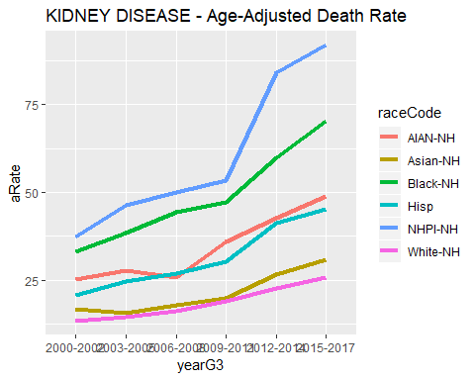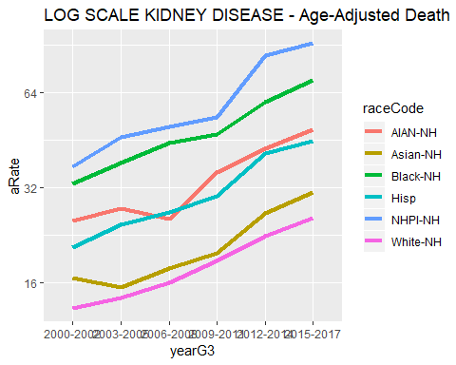

### * This shows the ratio of the death rate of African Americans to whites (the largest group), and shows the rate among African Americans is proportionally decreasing more rapidly than the white rate

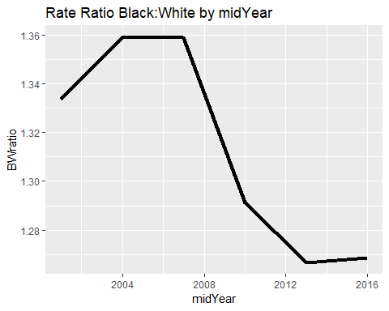

### * Nevertheless, the Black rate is higher than all other groups

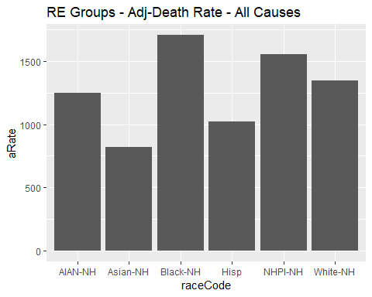

### * The rate is higher for blacks “total”“, and for black females and males. This higher rate is statitcally significant

## raceCode sex Ndeaths pop aRate aLCI aUCI  
## 1 AIAN-NH Total 7554 523600 1248 1219.0 1278.0  
## 2 Asian-NH Total 150200 15730000 819 814.8 823.2  
## 3 Black-NH Total 117700 6755000 1706 1697.0 1716.0  
## 4 Hisp Total 295800 46350000 1022 1018.0 1026.0  
## 5 NHPI-NH Total 5644 435000 1551 1509.0 1594.0  
## 6 White-NH Total 966400 45010000 1345 1342.0 1347.0

### * Looking at trends in age-adjust Years of Life Lost, the patterns are similary, but the differnece are even greater, since Blacks are differentially impacted by conditions with death at young age (e.g. homicide)

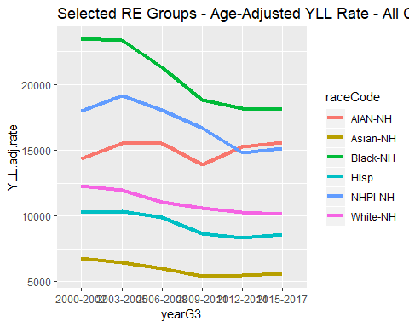

workX <- full_join(t.workA,tX,by="nameOnly")  
write_csv(workX,"raceWorkExploreAA.csv", na ="")